Vegetation Community Monitoring Protocol for the Heartland Inventory and Monitoring Network

Standard Operating Procedure 9: Measuring Overstory Canopy

Version 1.10 (2018)

Revision History Log:

| Previous Version # | Revision Date | Author | Changes Made | Reason for Change | New Version # |
| --- | --- | --- | --- | --- | --- |
| 1.0 | 2018 | S.A. Leis | Provide example and extracted from overstory SOP 7 (2009 protocol version). | Increased clarity. | 1.10 |
|  |  |  |  |  |  |
|  |  |  |  |  |  |

This SOP gives step-by-step instructions for sampling overstory canopy. Although previously known in the protocol (James et. al. 2009) as canopy cover, the correct term is canopy closure (Jennings et. al. 1999). Specifically:

*“canopy cover is the area of the ground covered by a vertical projection of the canopy, while canopy closure is the proportion of the sky hemisphere obscured by vegetation when viewed from a single point.”* (Jennings et. al. 1999).

The spherical concave densiometer HTLN has used to measure the canopy is a wide-angle instrument best suited for canopy closure (Paletto and Tosi 2009). Point-type measurements based on visual estimation, crown mapping, or intercept transects are considered canopy cover estimation methods. Canopy cover is helpful for understanding the stand structure and has implications for ground flora. Canopy closure is measured using a densiometer along the site’s two 50-m transects.

Equipment

See SOP 5-Monitoring Site Setup for basic plot set up equipment.

Additional equipment needed:

* Spherical concave Densiometer (2)
* Ground flora datasheet
* Compass

Procedures

Set up the site as described in SOP 5-Monitoring Site Setup. Canopy closure measurements are collected after the ground flora measurements in the 10-m2 plots along each transect.

Figure 9.0. Diagram showing transect A which is typically on the uphill side with Transect B 20 m away and parallel to it. Each transect is 50 m long. 

**Figure 9.0.** Diagram displaying paired transects creating the 20 m x 50 m site for tree species sampling with the smaller 10 m2 herbaceous vegetation sampling plots. Trees are measured in the 50 x 20 m block (1000 m2).

Densiometers are used at each 10-m2 plot (Figure 9.0) to observe amount of canopy closure. The spherical densiometer consists of a concave mirror with 24, ¼ inch squares engraved on the surface. Densiometer measurements are collected after the ground flora measurements are completed to avoid trampling the plot prior to collecting ground flora information. The observer stands over the plot center and collects four densiometer readings, one facing each of the four cardinal directions (N, E, S, W). Hold the densiometer level, 12” to 18” in front of body at breast height, so the operator’s head is not reflected in the grid area. The 24 squares on the densiometer are divided into 96 imaginary dots, assuming four equally spaced dots in each square of the grid (Figure 9.1A). Record the number of dots out of 96 that are covered by canopy (green leaves, and live branches twigs). If canopy openings are counted rather than canopy closure, subtract from 96 to obtain canopy closure. Densiometer readings are recorded on the top, right side of the ground flora data sheet. The number of dots covered by canopy will be converted to percent canopy closure (multiplied by 1.04) during the data summary process (not in the field).

An example densiometer image (Figure 9.1B) shows how you would mentally distribute dots on the densiometer surface and subsequently assess the canopy.

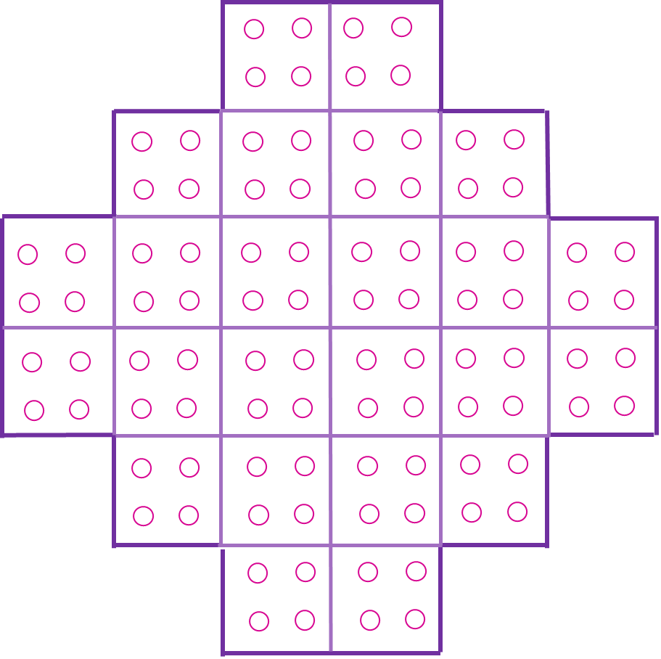 A. 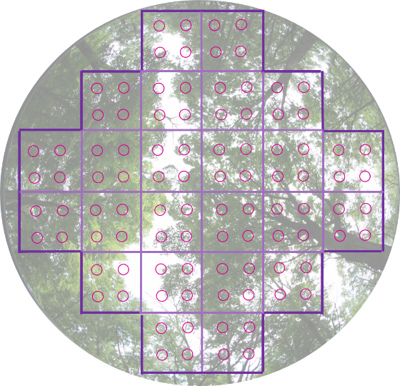B.

**Figure 9.1.** A. Illustration of the grid on the concave mirror of the densiometer. Note that red circles are *not* on the instrument, but dots are imagined by the observer. Area inside the circles represents the area to be evaluated. B. Illustration of a view of the canopy superimposed on a densitometer grid.

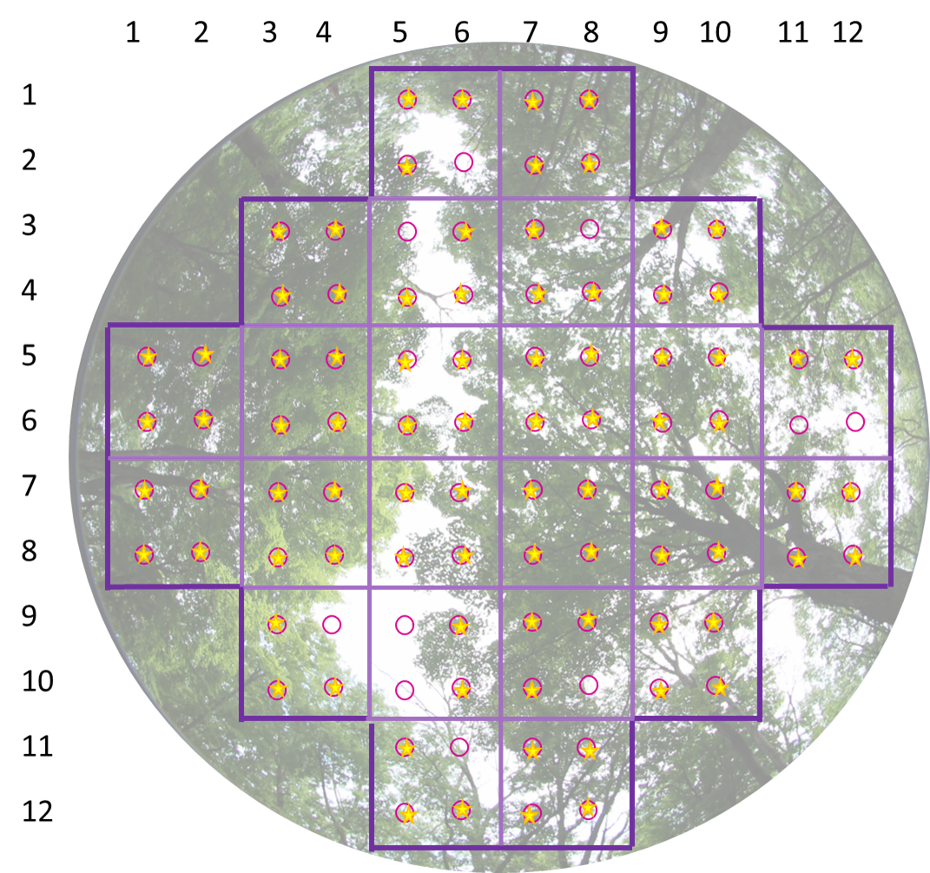

Figure 9.2. Key to Figure 9.1. Densiometer, record a score of 86 for the canopy represented by this photograph. Circles are observation points and yellow stars indicates canopy present.

Literature Cited

James, K. M., M. D. DeBacker, G. A. Rowell, J. L. Haack and L. W. Morrison. 2009. Vegetation community monitoring protocol for the Heartland Inventory and Monitoring Network. Natural Resource Report NPS/HTLN/NRR — 2009/141. National Park Service, Fort Collins, Colorado.

Jennings SB, Brown ND, Sheil D. 1999. Assessing forest canopies and understory illumination: canopy closure, canopy cover and other measures. Forestry 72(1):59–74.

Paletto, A. and V. Tosi. 2009. Forest canopy cover and canopy closure: Comparison of assessment techniques. European Journal of Forest Research 128:265-272.